Feature Image: Upgrade with the hottest watch brands.

Post Slug to make: most-popular-luxury-watch-brands-for-men

Title: The Most Popular Luxury Watch Brands for Men Right Now
Focus Keyword: luxury watches for men
Secondary Keyword:
Pre Owned luxury watches
Swiss Luxury timepieces
Diamond watch
luxury watches
luxury watch brands

Internal links:
mens luxury watches: https://swissiceco.com/pages/watches
pre owned luxury watches for sale: https://swissiceco.com/

Meta Description:
Explore top luxury watch brands for men today. See why Rolex, Patek Philippe & more captivate collectors from the rich Insights of Swiss Ice Co experts.
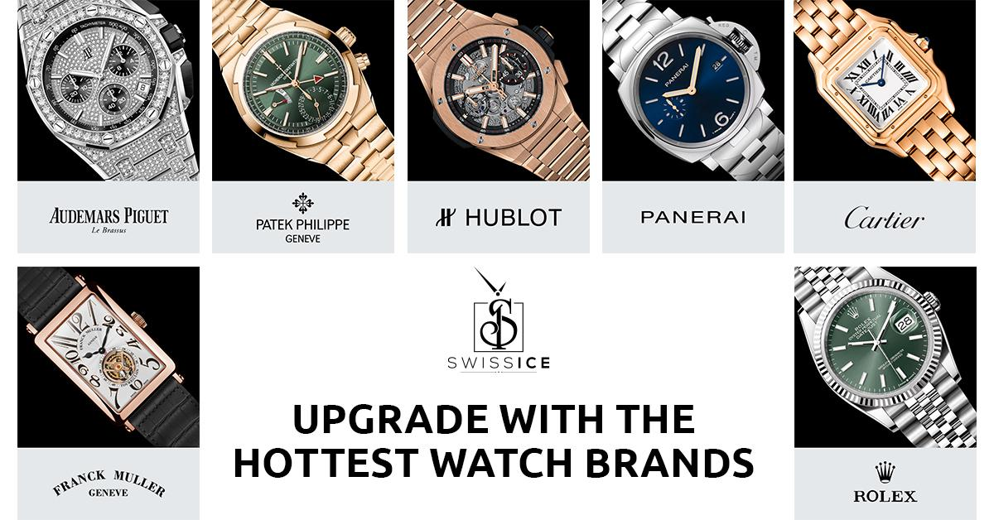

The Most Popular Luxury Watch Brands for Men Right Now H1
Have you ever caught yourself staring a little too long at someone else's wrist? That magnetic pull you feel towards a truly exceptional timepiece? That’s what we’re diving into today. If you’re reading this, chances are you’re feeling that itch, or maybe you’re saving up for your first serious watch, or you’re a seasoned collector always curious about the next big thing.
Whatever your story, pull up a chair. We’re not just talking about telling time, but we’re talking about tiny mechanical miracles, heritage you can wear, and finding that perfect piece that feels like you. Here in this blog, you will learn about the most popular luxury watch brands in the world right now.

Why Spend Money on a Luxury Watch? H2
Yeah, your phone tells time. So does your microwave. We get it. But why a luxury watch? That’s a whole different beast. Consider carrying centuries of humanity's ingenuity on your wrists. It is the reassuring sound of the crown and the mesmerizing feeling of quality brought by its weight.
The Swiss world-famous luxury watches did not go legendary accidentally, but because of their maniacal attention to detail, tenets of their success which have been inherited by generations of supreme timepiece watchmakers. More than anything, though, a great watch becomes your silent partner. It’s there for the big promotion, the wedding day, the quiet moments of pride. It speaks volumes without saying a word, a testament to what you value.

The Big Names You Know and Love H2
These luxury watches for men are the legends. The ones that consistently make watch lovers weak in the knees.

Rolex: The King of Recognition H3
Let's be real, when most people think of "luxury watch brands," they picture that crown logo. And there's a reason. Rolex isn't just hype. The Rolex brand is among the pioneers in the watch industry, which invented the modern waterproof watches. Here are some famous Rolex watch models that you can find in our collection:
- Date
- Datejust
- Datejust 41mm
- Datejust II
- Datejust II 41mm
- Datejust Turnograph
- Datejust TurnoGraph
- Daytona
- GMT Master II
- GMT-MASTER II
Every single one of the above-mentioned models is tough, reliable, and holds its value like crazy. If you want to save some money and own something with a historical touch, you can consider a pre owned luxury watch Rolex. For any customer who wants to step into mens luxury watches, Rolex is the first love.

Patek Philippe Pure Watchmaking Art H3
If Rolex is the popular king, Patek Philippe is the top choice of family-owned businessmen. It features like micro miniature finished by hand, complications that trace the phases of the moon over decades are what make it special.

Audemars Piguet The Bold Game Changer H3
AP shook things up big time in 1972. It created the whole "luxury sports watch" category overnight. Today, that Royal Oak (and its beefier cousin, the Offshore) is still a massive symbol of modern style. AP doesn't rest, though, and their Code 11.59 line pushes design further. They mix deep tradition with a fearless edge, perfect for guys who want standout luxury watches for men.

The Amazing Contenders with Rising Stars and Icons H2
Beyond the "Big Three," these brands are seriously impressive and gaining even more fans.

Omega Adventure and Innovation H3
Omega’s got stories to tell. Strapped to astronauts' wrists on the moon (the Speedmaster "Moonwatch”). On James Bond's arm for decades (the rugged Seamaster). They offer incredible tech, like their Co-Axial escapement that keeps things crazy accurate for longer. Whether you love the sporty Speedmaster, the dive-ready Seamaster 300M, or the classic Constellation, Omega delivers serious performance for your money. Concerning history, performance, and style, this is a solid choice in mens luxury watches.

Jaeger LeCoultre The Watchmakers Watchmaker H3
Insiders call JLC "the watchmaker's watchmaker" ("La Grande Maison"). Why? They're masters of the movement. They actually make movements for other top brands! Their own watches? Stunning. Think the super-slim Master Control, the genius Reverso with its swiveling case (born for polo players!), or mind-blowing complications like the Gyrotourbillon. JLC is for the guy who appreciates quiet, under-the-radar excellence in Swiss luxury timepieces.

Vacheron Constantin Old World Elegance H3
Founded way back in 1755, Vacheron Constantin is the oldest going concern in watchmaking. That heritage shows. They craft timepieces of pure elegance and insane detail. Part of the "Holy Trinity" with Patek and AP, their Patrimony and Overseas lines are pure class. They excel at beautiful finishing and complex watches that whisper sophistication rather than shout. A cornerstone for true connoisseurs.

Cartier Style Icon Supreme H3
Yes, Cartier is famous for jewels, but their luxury watches for men? Absolute icons. Their power is design, pure and simple. The Tank, inspired by WWI tanks? Timeless rectangle, pure elegance. The Santos was made for a pilot friend back in 1904? Arguably the first proper men's wristwatch! Cartier watches are statement pieces that blend art with watchmaking. And if you fancy a touch of discreet shine, they integrate diamonds into some models like no other.

IWC Schaffhausen Built for Purpose H3
IWC speaks the language of engineering. Big, legible pilots' watches are their heart. You can think of the massive Big Pilot or the classic Mark series. They scream adventure and precision. Then you have the Portugieser line, which offers the elegant complications in a larger, distinctive case. IWC is for the guy who loves tools and mechanics.

How to Choose Your Perfect Timepiece? H2
With so many incredible options, picking one is deeply personal. Don't rush it. Here’s how I’d approach it:

What’s Your Style: H3
Vibe Sporty tool watch? Sleek dress piece? Vintage charm? Modern edge? Picture it on your wrist daily.

Be Real About Budget: H3
Luxury watches for men range widely. Set a comfortable limit. Remember, the pre owned luxury watches market is fantastic for finding gems at better prices or snagging discontinued models. If you are looking for pre owned luxury watches for sale, Swiss Ice Co must be your top priority because we have everything that you are looking for.

Do Your Homework: H3
Fall down the rabbit hole! Read about brands, specific models, their history, size, and movement type. Watch reviews, join forums. Knowledge is power (and fun!).

Try It On Seriously: H3
Photos lie. How a watch feels on your wrist is everything. Is it too heavy? Too big? Just right? Visit authorized dealers or trusted pre-owned spots. Get that wrist time.

Understand the Heartbeat: H3
Most high-end luxury watches, especially Swiss luxury Diamond watches, are mechanical (automatic or hand-wound). They're marvels of engineering. Quartz is accurate but lacks the soul for many collectors. Know the difference.

Final Thoughts: H3
Why are such brands of men luxury watches so fascinating forever? It is due to their centuries of craft literally poured into small machines, designs that become part of our culture, and that fundamental, potent thing of strapping down a chunk of history and art onto your wrist.
Whether it be the lush reliability of a Rolex Sub, the awe-inspiring mechanics within a Patek, that classy Royal Oak bezel of AP, or that slim, clean Tank that Cartier has, the brands will have and display a different story as to what luxury and style are. In search of that elusive item, be it a new or a cherished pre owned luxury watch, discovering this world will lead you on an adventure.
Go slowly. Have fun. Acquire the narratives. Discover the watch that not only tells the time, but tells your time. After thorough research, you can easily find your dream watch.
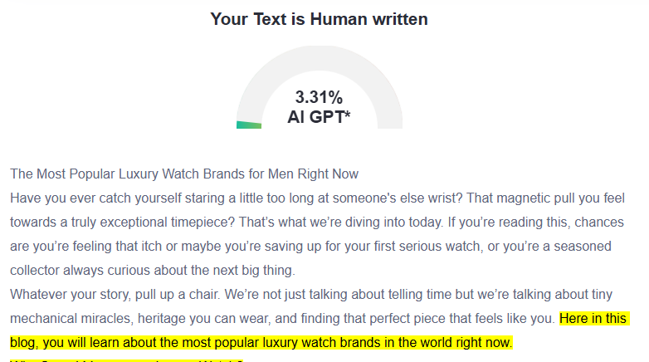

GMB Description:
Dreaming about a luxury watch that feels like it was made just for you? Our latest blog dives into the most sought-after men's timepieces right now, written by fellow watch lovers who get that thrill when a second hand glides perfectly. We explore why icons like Rolex, Patek Philippe, and Audemars Piguet capture hearts generation after generation, along with rising stars like Omega and Cartier. Get real talk about Swiss luxury timepieces and what makes them tick. Learn why the pre owned luxury watches for sale market is booming, offering innovative ways to own legendary pieces or find discontinued gems. Whether you're hunting for your first serious mens luxury watch or adding to a collection, we break down what makes each brand unique. From Rolex's rugged dependability to Patek's breathtaking mechanics, our experts share practical tips for choosing your perfect match. Understand how to navigate styles, budgets, and the emotional pull of a timepiece that becomes part of your story. Join us at Swiss Ice Co for a genuine conversation about craftsmanship that stands the test of time, where every tick whispers heritage and personal milestones.

